

CODE SMELLS&REFACTORING
27TH MAY2025
BY ZAINABKHAN
(FA22-BSE-032)

COMSATS UNIVERSITY ISLAMABAD, ATTOCK CAMPUS
SOFTWARE RE-ENGINEERING

ASSIGNMENT NUMBER:03

SUBMITTED TO:
DR. TAHIRA SADAF

QUESTION:
- Identify code smells in code.
- Apply refactoring to remove code smells.
- Compare class diagram before and after refactoring.

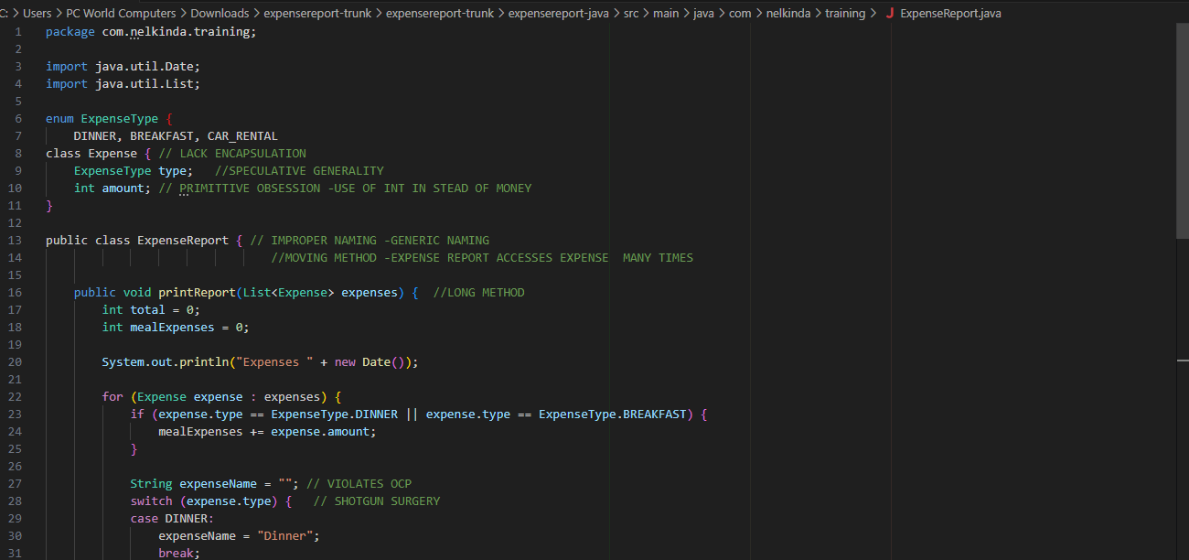
- CODE SMELLS IN THE CODE:

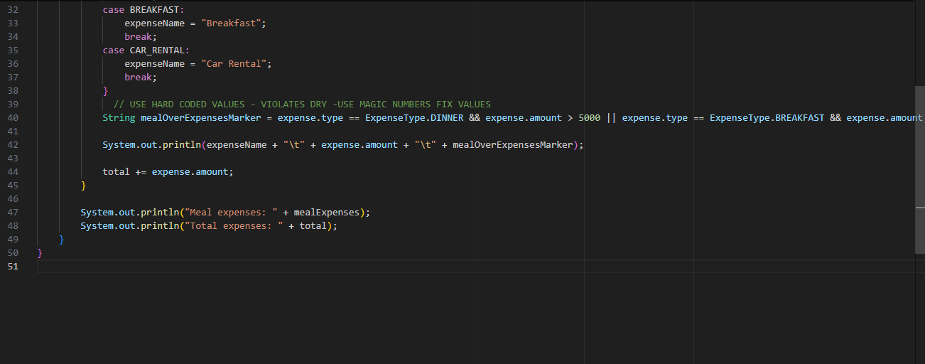
- EXPLAINATION:
Lack of Encapsulation: Expense fields are not private.
Primitive Obsession: Using int for money values.
Improper Naming: Class name ExpenseReport too vague.
Long Method: printReport() handles too much logic.
Open-Closed Principle Violation: Switch-case requires editing on enum change.
Shotgun Surgery: Changes required in multiple places if new types are added.
Magic Numbers: Violation of don’t repeat your-self 5000 and 1000 hardcoded.
Duplicated Logic :Meal logic and amount handling not abstracted.
Inappropriate/lack of Main Method: This is not a formal code smell but it's a practical smell in terms of runnability and design.
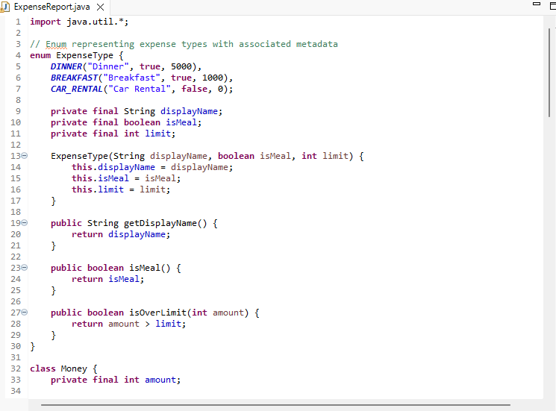
- CODE REFACTORING:
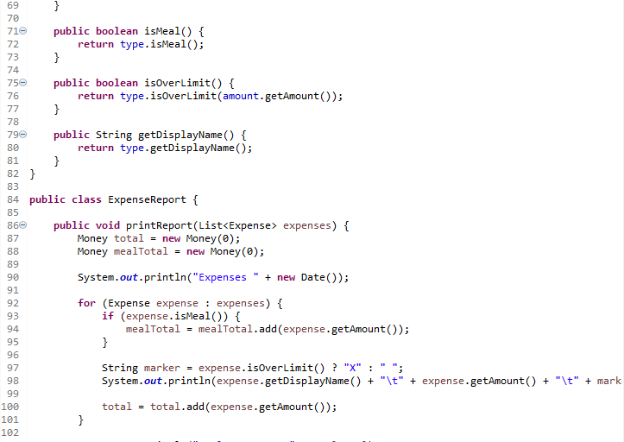
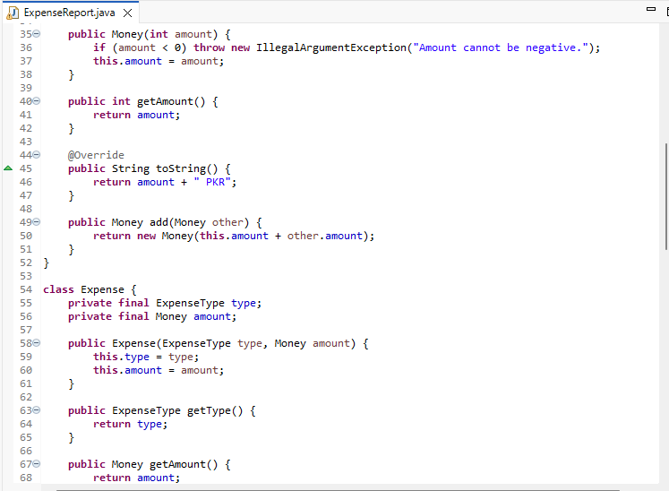
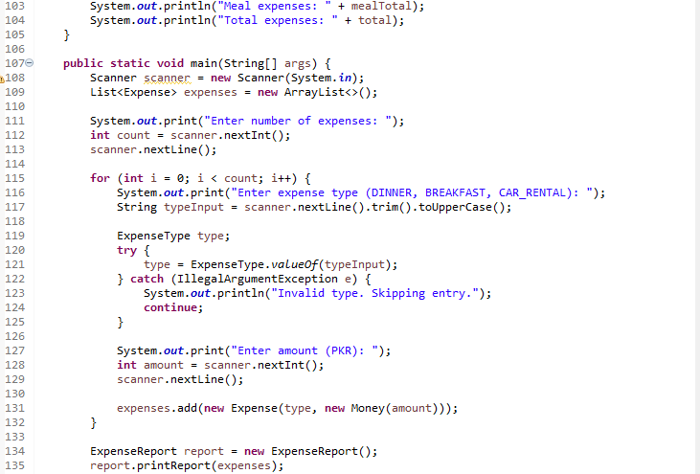
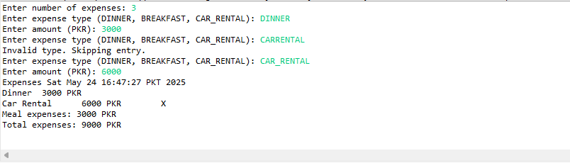
CODE OUTPUT:

- CODE SMELLS REMOVED :
- HARD CODED VALUES (Magic Numbers)
Smell: Using raw numbers like 5000, 1000 scattered throughout the code without explanation.
In code: Expense limits (5000, 1000, 0) are stored as parameters inside the enum ExpenseType
DINNER("Dinner", true, 5000),
BREAKFAST("Breakfast", true, 1000),
CAR_RENTAL("Car Rental", false, 0);
How it’s improved: Instead of hardcoded literals everywhere, the limits are encapsulated inside the enum constants, improving readability and maintainability.
- Primitive Obsession
Smell: Using primitive types (like int) directly for money amounts instead of an abstraction.
In code:
class Money {
private final int amount;
...
public Money add(Money other) {
return new Money(this.amount + other.amount);
}
}
How it’s improved:Wrapping int into Money improves type safety, expresses domain intent, and isolates money-related logic in one place.
- Duplicated Logic
Smell: Repeating code for checking if an expense is a meal or over the limit.
In code:
This logic is encapsulated inside the ExpenseType enum and delegated in the Expense class.
public boolean isMeal() {
return type.isMeal();
}
public boolean isOverLimit() {
return type.isOverLimit(amount.getAmount());
}
How it’s improved: No repeated logic outside; checking "is meal?" or "over limit?" is done by querying the type.

- Long Method
Smell: Very long methods that do too much.
In code:
Print Report is clear and concise, handling only one responsibility — printing the expense report.
Input reading logic is neatly separated in main.
How it’s improved: Clear separation of concerns, avoiding long unwieldy methods.

- Inappropriate Naming or Formatting
Smell: Spaces in names, inconsistent casing.
In code:
Enum constants are in uppercase, class and method names use proper camelCase, and ExpenseType uses descriptive names with displayName property for user-friendly display
DINNER("Dinner", true, 5000)

- Encapsulation:
Switch or If-Else Chains
Smell: Long switch or if-else statements to handle expense types or logic.
In code: The ExpenseType enum replaces switch statements by encapsulating metadata and behavior.
enum ExpenseType {
...
public boolean isOverLimit(int amount) {
return amount > limit;
}
}
How it’s improved: Encapsulation reduces conditionals and makes the code more maintainable.

- Lack of Input Validation
Smell: No validation on user input could lead to runtime exceptions or invalid data.
In code: You validate negative amounts inside Money constructor (line ~24).
java
if (amount < 0) throw new IllegalArgumentException("Amount cannot be negative."). Handle invalid expense types with try-catch in main (lines ~70-77):
try {
type = ExpenseType.valueOf(typeInput);
} catch (IllegalArgumentException e) {
System.out.println("Invalid type. Skipping entry.");
continue;
}

- Adherence TO Open & Close Principle:
ExpenseType enum encapsulates behavior per type:
In code:
enum ExpenseType {
DINNER("Dinner", true, 5000),
BREAKFAST("Breakfast", true, 1000),
CAR_RENTAL("Car Rental", false, 0);
}
Each type has its own data and behavior (isMeal, limit, displayName).The isOverLimit() logic depends on the type itself, so if you want to add a new type, e.g.: LUNCH("Lunch", true, 3000),
You can add it without changing any other logic in Expense, Money, or ExpenseReport.
No type-specific logic in report generation:
String marker = expense.isOverLimit() ? "X" : " ";
The ExpenseReport doesn’t care how an expense decides if it's over the limit. It just asks: expense.isOverLimit().
This means you can extend behavior (add new expense types or limit logic) without modifying print Report().
- Adherence To Don’t Repeat Your-Self:
Logic for "isMeal", "limit check", etc. is centralized:
Code don’t repeat logic like:
if (type == DINNER || type == BREAKFAST)
Instead, you use:
expense.isMeal();
Where isMeal() is defined only once in ExpenseType:
public boolean isMeal() {
return isMeal;
}
Totals are computed using reusable logic:
mealTotal = mealTotal.add(expense.getAmount());
total = total.add(expense.getAmount());
The Money.add() method encapsulates addition logic.
No repeated amount + amount logic — avoids redundancy and allows consistent formatting (toString()).
- Code AVOIDS Shotgun Surgery
Centralized Expense Type Logic via enum ExpenseType
Instead of scattering limit, meal-checking, and display logic across your application, it’s centralized inside the enum:
enum ExpenseType {
DINNER("Dinner", true, 5000),
BREAKFAST("Breakfast", true, 1000),
CAR_RENTAL("Car Rental", false, 0);
private final String displayName;
private final boolean isMeal;
private final int limit;
...
}
Example: Add a New Expense Type — LUNCH
Imagine you want to add:
LUNCH("Lunch", true, 3000)
In a poor design (pre-refactor), you might have to:
Update:
- The printReport() method to check for “LUNCH”
- Logic in main() to handle “LUNCH”
- isOverLimit() logic somewhere else
- Display formatting for “LUNCH”
That’s shotgun surgery — the change requires modifying many areas.

main() Makes the Program Executable
In Java, the entry point of any program is the main() method:
public static void main(String[] args)
Why it's needed:
- Without main(), it was not clear where to start execution.It’s like the front door to application — the only way users can interact with it without writing extra code or tests.
So adding main():
Makes your program runnable on its own
Enables you to compile and run the class.
Improved main() Enhances Code
- Improves Readability and Structure
Old code:
System.out.print("Enter amount (PKR): ");
int amount = scanner.nextInt();
scanner.nextLine();
New version:
int amount = readPositiveIntWithPrompt(scanner, "Enter amount (PKR): ");
This moves messy logic out of main() into helper methods, so your main() reads like a story instead of a mess of technical details.
- Improves Input Validation
You now validate input like this:
int count = readPositiveInt(scanner);
No more crashing the program if the user enters text instead of a number.
- Handles Invalid Expense Types
type = ExpenseType.valueOf(scanner.nextLine().trim().toUpperCase());
which throws an exception if invalid,
now code is ,
ExpenseType type = readExpenseType(scanner);
if (type == null) {
System.out.println("Invalid type. Skipping this expense.");
Continue;}
- Comparison Of Legacy Code Class Diagram With Refactored Class Diagram:
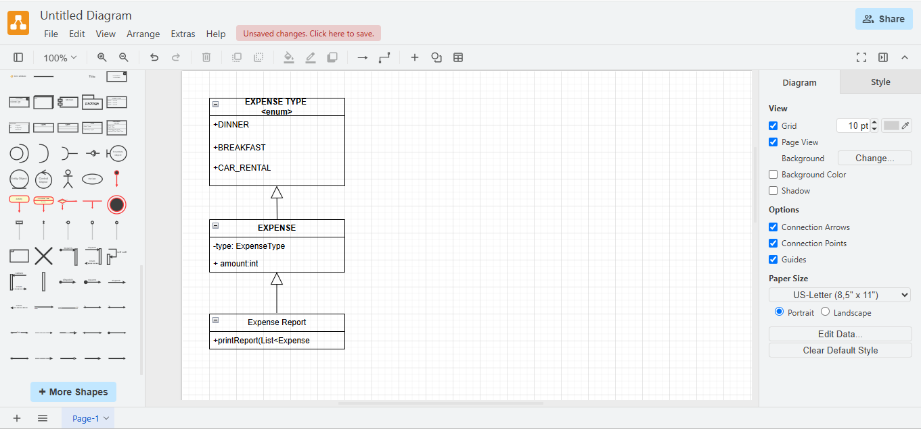
- LAGACY CODE CLASS DIAGRAM:

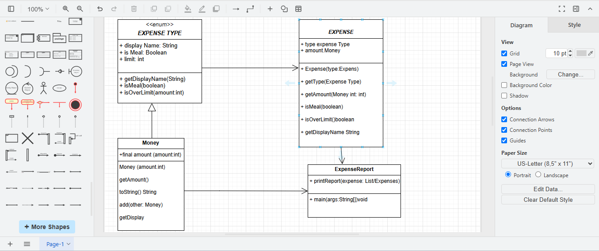
- REFACTORED CODE CLASS DIAGRAM:

